To whom it may concern,
We, the EJ Feltes Memorial Foundation, are writing to local businesses to request any donations to put together baskets for our Chinese Auction, see if any business is interested in setting up a vendor tent for families to check out, request any food donations that can be picked up . Our next event is our Community Fun Event to be held on July 27th at John A Antoline park in Monaca, PA. This is our giveback to the community event- we try to supply bounce houses, food, drinks, and treats for families.
Our goal for this event is to raise awareness for our foundation to be able to sponsor as many children’s swimming lessons as possible. Please consider helping us make that goal a reality. We are coordinating with the Beaver County YMCA to reach as many children as possible. We are also looking at expanding to other YMCA’s. Another longer-term goal for our foundation is to provide Water Safety presentations at the local school districts and daycares. If you have any child or facility you would like us to contact, you can also pass that along to us or share our information with them.
If you have any questions or concerns, and to schedule any pick up of items- please contact Christina Thompson at 724-831-0286. You can also email the foundation if that works best ejfeltes.foundation@gmail.com . Thank you for your time and consideration!

Thank you,
EJ Feltes Memorial Foundation Board
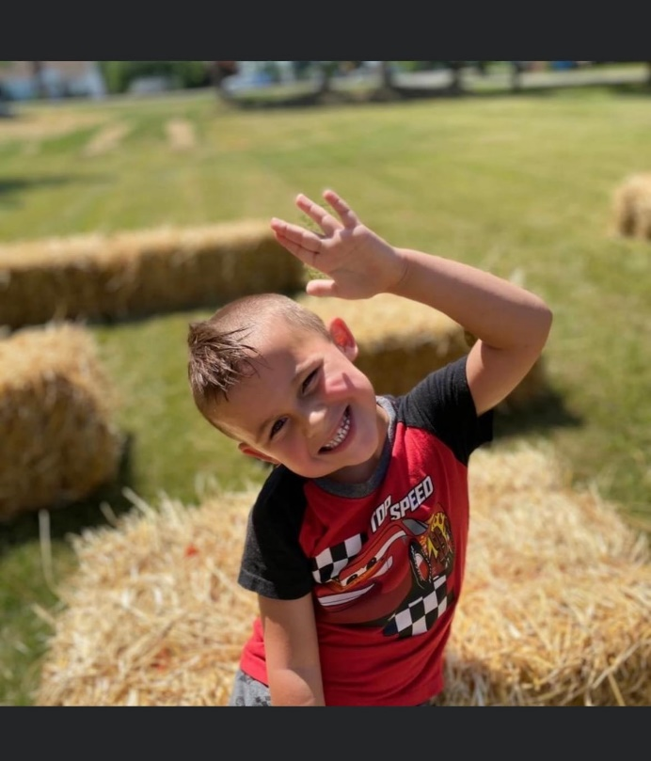
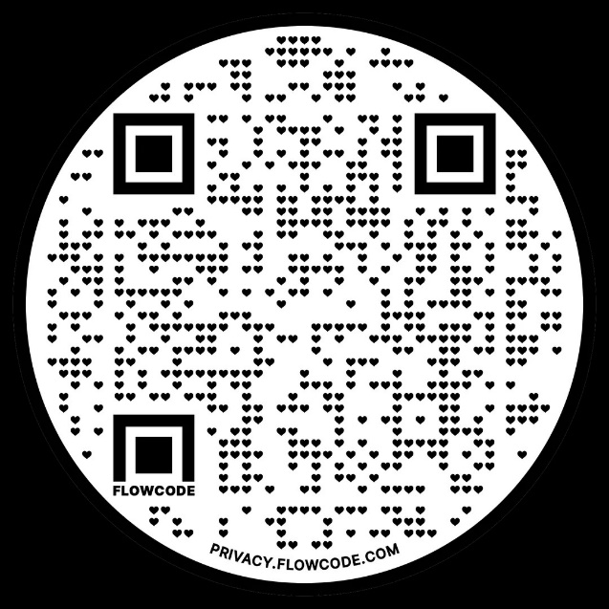
Our website: ejfmemorialfoundation.org
Our Facebook:
EJFMF

Our QR code: will lead you to our Donate/Event information. Click through to discover more.

